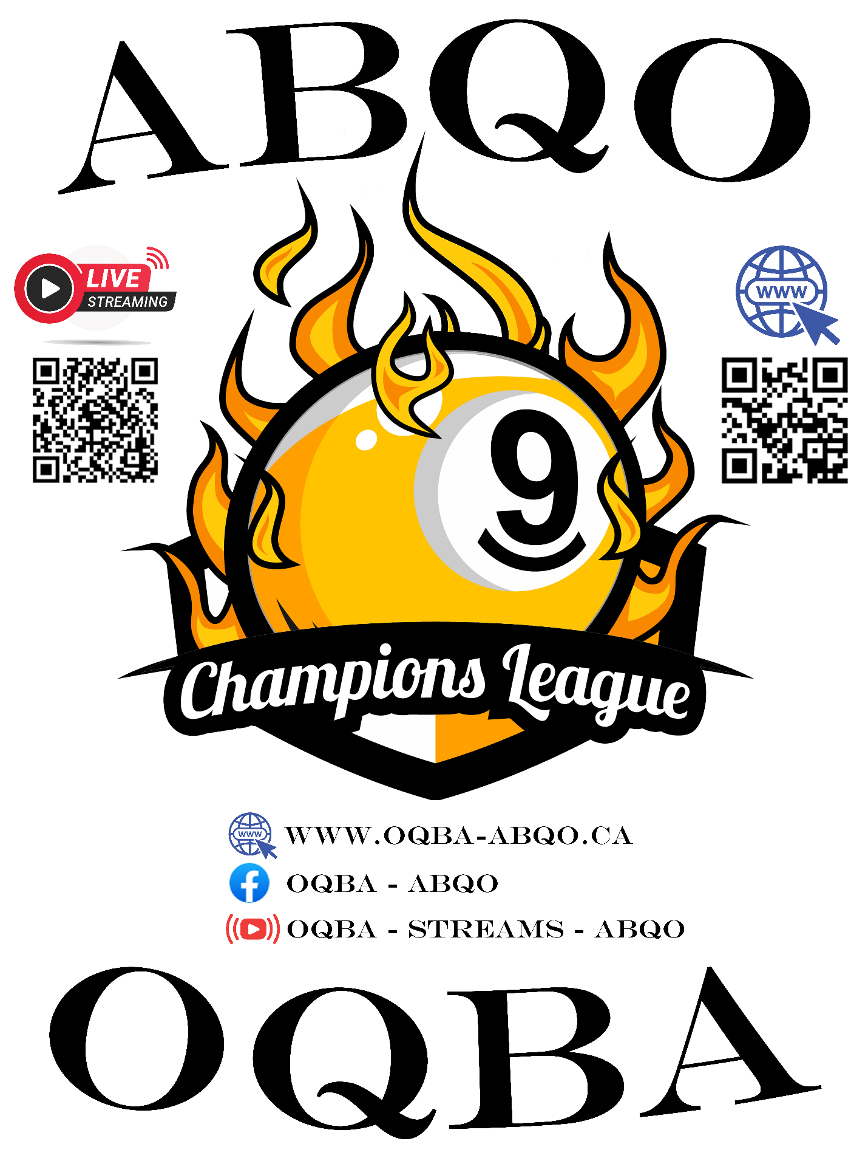

2022-2023 Season

General Information (OQBA Only)
 | Amateur (SP or less) | Professionnal-Open
Money saved already (the POT)  (will go up during the season) | 2 000$ | 1 000$
Number of tournaments | 6 + 1 Final | 2 + 1 Final
Number of pool halls | 2 | 2
Calcutta | Yes | Yes
Money added per tournament | 2000$ | 5000$
Total invested this season | 14 000$ + the final POT | 15 000$ + the final POT
Tournaments required for the finals | 2 | 1
Annual membership fee | 15$ | 15$
Fee per tournament  (Goes directly into the POT) | 5$ | 5$
Membership benefits | Laser engraved membership card  Statistics in 1Stat.ca | Laser engraved membership card  Statistics in 1Stat.ca
Streaming | Yes | Yes
2e Life Tournament (Sunday) | Yes | Yes
No. Of days per tournament | 2 | 2
Trophies | Yes | Yes
Seasonal Ranking | Yes | Yes
Regional tournaments | Yes | Yes

New additions and specialties
- Addition of a Professional format to the OQBA circuit : OQBA-Pro (ABQO-Pro in french)
- Laser engraved membership cards with QR Codes
- Magic Racks
- Call shot on the 9 in the Amateur
- New ranking system (1Stat)
- OQBA Shirts for sale
- Sound on the live streams
- THE POT: + 5.00 $ fees per player for each tournament which goes into the final for each respective circuit (Amateur or Pro)

Game format for OQBA-Pro Tournaments
- Double elimination
- 9-ball
- Call-Shot
- All fouls
- Winner break
- Winner Side races :
  - Races to 10 (Pro) and 9 (Any other class)
- Losers Side Races :
  - Races to 9 (Pro) and 8 (Any other class)

- Maximum 32(64,128) players (depending on the online registration…)
- Fees to play :
  - Professionnal : 150$ + 5$ for the pot
  - Open : 125$ + 5$ for the pot
  - Seasonal OQBA-Pro (15$) membership if not paid previously
  - Gives access to the finals of the OQBA-Pro, a seasonal ranking, your membership card, statistics, etc…

Game format for OQBA 2nd Life Tournaments
- You have just respawned my friend… but be careful : you’re not very strong!
- Single elimination
- Races to 9
- Semi-Pro or less (Amateur only)
- Must have participated in the main tournament
- 20$ entry fee
- 500$ added guaranteed

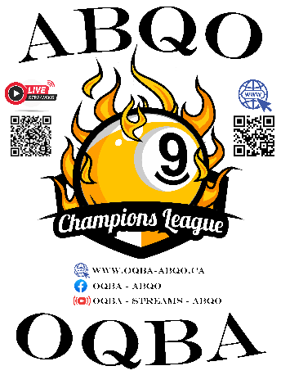
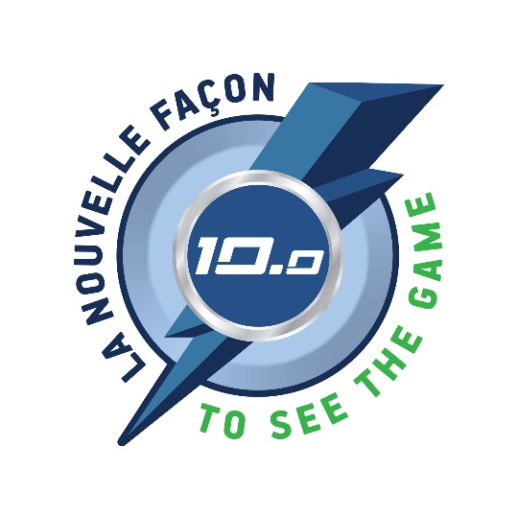
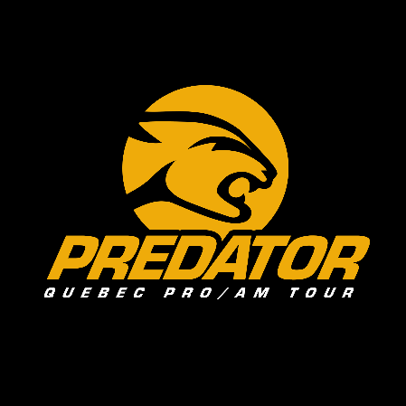
Partnerships

The OQBA is in partnership with 2 other Québec-side circuits this year : The Predator Québec Pro/Am Tour, and The 10.0 Challenge circuits

What does that mean?
These partnerships allow us to have other events than the OQBA in our region, and allows us to have OQBA tournaments in other regions as well. This year, it translates to this :
2 combined Professional level events between OQBA and Predator Quebec Pro/Am Tour, which will each count towards a participation to be eligible for the finals of each circuit :


- 1x Opening [Predator-Pro / ABQO-Pro] in the Outaouais (Doolys Ottawa)
(27-28 August)

  - Tournament format : Predator-Quebec Pro-Am Tour
  - Money added : 7 000$
  - Hall : Doolys Ottawa
  - 2 days, with the Predator-Amateur on Sunday

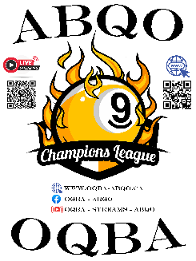
  - Fees: Predator-Quebec Pro-Am Tour fees ($$?, + $?)
(nb : if a player wants to play in an OQBA-Pro event, they will still have to pay for the membership fees of the OQBA organisation at that event, but playing here counts for the Pro finals, as discussed with Mathieu Charlebois)
- 1x Opening [ABQO-Pro / Predator-Pro] in a region (St-Hyacinte)
(the 1st and 2nd of Octobre 2022)
  - Tournament format : ABQO-Pro
  - Money added : 7 000$
  - Hall : Doolys de St-Hyacinte
  - 2 days, OQBA 2nd Life on Sunday

  - Fees : ABQO-Pro (15$ + 5$)
(nb : if a player wants to play in a Predator Quebec Pro/Am Tour, they will have to pay their membership fees with them during this other event, however, playing in this event still counts for the Predator Quebec Pro-Am Tour finals, as discussed with David Deschênes)
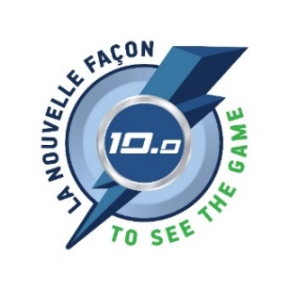
- 1x Challenge 10.0 - Amateur (2610 or less) in Outaouais (Doolys Ottawa)
(Novembre 26th and 27th 2022)
  - Tournament format : 10.0 2610 or less
  - Money added: 1010$ minimum
  - Hall : Dollys Ottawa
  - 2 days, 10.0 2nd chance on sunday?
  - Fees required: 10.0 2610 or less
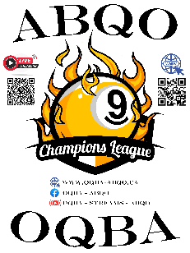
- 1x Event OQBA-Amateur in 1 regional hall (St-Hyacinthe)
(DATE TBD)
  - Tournament format: OQBA-Amateur
  - Money added : 2000$
  - Hall: TBD/ST-JEAN/ST-HYACINTE
  - 2 days, OQBA 2nd Life on Sunday

  - Fees : OQBA-Amateur (15$ + 5$)

Calendar of events

2022
Date | Location | Format | Money Added
27-28 August  2022 | Doolys Ottawa | Combined Opening,  Format Pred-Pro  (Game format Predator) | 7 000$ |   
September 3-4 | Doolys Ottawa | ABQO-Amateur Opening | 2000$
October 1-2nd 2022  2022 | St-Hyacinte | Combined Opening,  Format ABQO-Pro  (Game format ABQO-Pro) | 7 000$ | 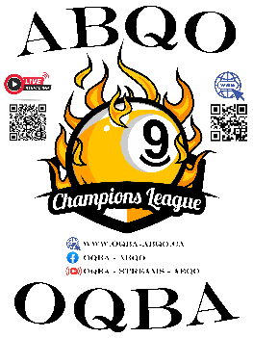  
Octobre 29-30  2022 | Doolys Ottawa | ABQO-Amateur | 2 000$
November 12-13  2022 | Doolys Ottawa | ABQO-Pro | 5 000$
November 26-27  2022 | Doolys Ottawa | 10.0 - Amateur | 10 10$ | 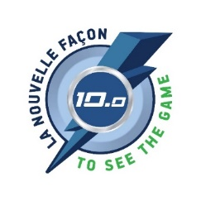

2023
Date | Location | Format | Money Added
21-22 January | OUVERT | ABQO REGION |  | OUI
4-5 février | OUVERT | ABQO REGION? |  | OUI
Feburary 18-19  2023 | Doolys Ottawa | ABQO-Amateur | 2 000$
4-5 mars | OUVERT | ABQO REGION? |  | OUI
March 18-19  2023 | Doolys Ottawa | ABQO-Amateur | 2 000$
1-2 avril | OUVERT | ABQO REGION? |  | OUI
April 15-16  2023 | Doolys Ottawa | ABQO-Pro FINALS | 5 000$ + POT  (min 1k) | 6K+ FINALS
29-30 avril | OUVERT | ABQO REGION? |  | OUI
May 13-14 | Doolys Ottawa | ABQO-Amateur FINALS | 2 000$ + POT  (min 3k) | 5K+ FINALS

